FSD Laboratory 02

## Name : Rajdeep Chauhan

## Roll no. : PA18

**Batch : A1**

## PRN : 1032211100

**Aim:** Design and develop a responsive web page using Bootstrap front end framework.

## Objectives:

1. To understand HTML tags
2. To learn the styling of web pages using CSS
3. To learn Bootstrap Front End Framework.

**Theory:**

# Bootstrap Grid System.

The Bootstrap grid system is a responsive, mobile-first grid system that allows you to create flexible and responsive layouts for your web projects. It's one of the core features of the Bootstrap front-end framework and is based on a 12-column grid system. This system helps developers create consistent and visually appealing designs that adapt to various screen sizes, from large desktop monitors to small mobile devices.

Here are some key aspects of the Bootstrap grid system:

* **12-Column Grid:** Bootstrap's grid system is divided into 12 equal-width columns. You can use these columns to structure the layout of your web page. Columns can be combined to create rows.
* **Rows:** Rows are horizontal containers that hold your columns. Rows ensure that the columns align properly and are evenly spaced within the grid.
* **Responsive:** The Bootstrap grid system is inherently responsive. By default, columns will stack vertically on smaller screens and expand horizontally on larger screens. This responsiveness is achieved using CSS media queries.
* **Grid Classes:** Bootstrap provides a set of CSS classes to define the width of columns at different screen sizes. These classes are typically named col-<size>-<number>, where <size> represents the screen size (e.g., sm for small, md for medium, lg for large), and <number> represents the number of columns the element should span. For example, col-md-6 would create a column that spans 6 out of the 12 available columns on medium-sized screens.
* **Offsetting Columns**: You can also offset columns using the offset-<size>-<number> classes. This allows you to create gaps between columns.
* **Nesting:** You can nest columns within other columns to create complex layouts. Nested columns have their own set of 12 columns, independent of the parent columns.

# Bootstrap .container and .container-fluid class.

In Bootstrap, the .container and .container-fluid classes are used to create responsive containers for your web content. They are crucial for structuring the layout of your web pages and ensuring that your content looks good on various screen sizes. Here's an explanation of each class:

### .container Class:

The .container class creates a fixed-width container that centers your content horizontally on the page. It ensures that your content does not span the entire width of the screen, making it easier to read and providing a consistent and controlled layout.The

.container class has a maximum width that varies depending on the screen size: On extra-small (xs) and small (sm) screens, it has a maximum width of 100% of the viewport width. On medium (md) screens and larger, it has a fixed maximum width that depends on the Bootstrap grid breakpoints.

### .container-fluid Class:

The .container-fluid class creates a full-width container that spans the entire width of the screen. It adjusts its width according to the screen size and adapts to various screen resolutions, making it suitable for creating fluid and responsive layouts. Unlike the

.container class, which has a fixed maximum width on larger screens, .container-fluid expands to fill the entire available space, making it ideal for designs that want to utilize the full width of the screen.

**Use .container** when you want to create a centered and fixed-width layout, ensuring that your content is readable and not excessively wide on larger screens.

**Use .container-fluid** when you want your content to span the entire width of the screen, creating a fluid and full-width layout that adapts to different screen sizes.

# FAQ:

1. **What is a responsive website?**

A responsive website is a website design approach that aims to ensure that web pages look and function well across a wide range of devices and screen sizes. The primary goal of responsive web design is to provide an optimal user experience, regardless of whether visitors access the site on a desktop computer, laptop, tablet, smartphone, or other devices with varying screen dimensions and resolutions.

Responsive web design has become a standard practice in modern web development because it offers several advantages, including: Improved user experience and accessibility for a diverse audience using different devices.A single codebase that serves multiple platforms, reducing development and maintenance efforts.Better SEO performance since search engines prioritize mobile-friendly websites in search results.Increased engagement and lower bounce rates, as visitors are more likely to stay on a site that works well on their device.

# How Bootstrap helps to design a responsive website?

Bootstrap is a popular front-end framework that plays a significant role in designing responsive websites. It provides a set of pre-designed CSS styles, JavaScript components, and a responsive grid system that simplifies the process of creating responsive web layouts.

By using Bootstrap, web developers and designers can leverage these responsive design features and components to save time, ensure cross-device compatibility, and deliver a consistent and user-friendly experience across various screen sizes and devices. It streamlines the process of building responsive websites and allows you to focus on creating content and functionality rather than starting from scratch with CSS and JavaScript

# Output: Screenshots of the output to be attached.

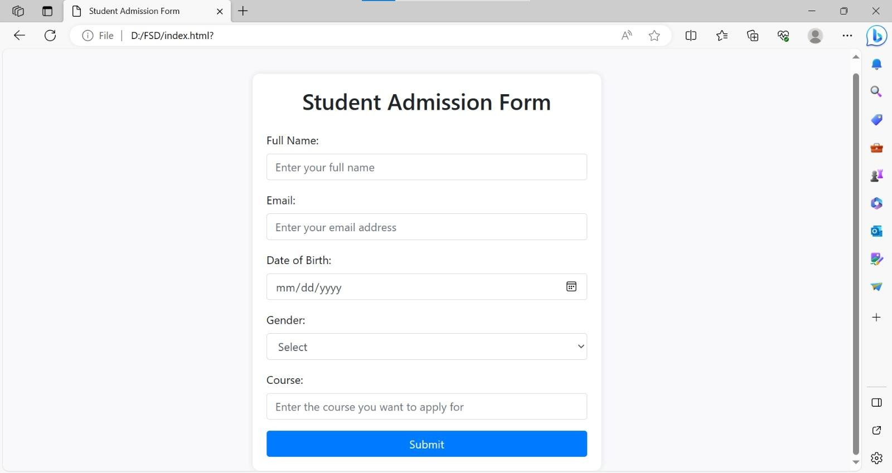

School of Computer Engineering & Technology Class: Third Year B.Tech CSE (Semester V) **Course: Full Stack Development**

